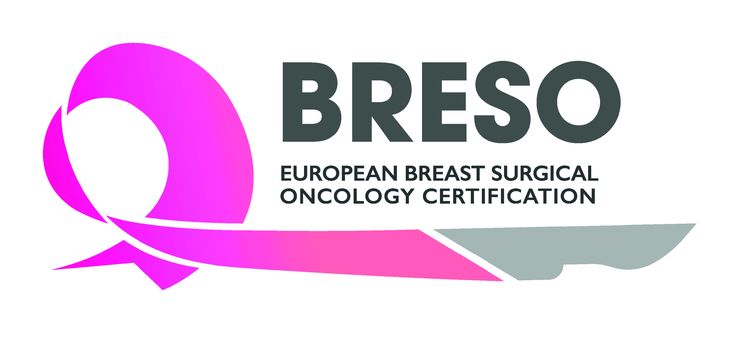

BRESO Certification Application (Prospective)
This application is to be completed by trainees or recently qualified breast surgeons (within 5 years of completion of training). Senior surgeons with more than 5 years’ experience at consultant/attending level can however apply for retrospective certification. E-mail info@breastsurgeoncertification.com for more information.

Your details:

Title
Family name
First name
Date of birth
Institute
Department
Address
Zip code
Town
Country
Phone number
e-mail

Member of | ESO  ESSO  EUSOMA  EUBREAST  G.Re.T.A.  Other:

Specialty | General Surgery  Gynaecology  Other:

Please describe your undergraduate and postgraduate medical education
*Medical Degree (please provide certified copies of the relevant certificates translated in English if not in English originally)

Institution | Year / period (from ... to ...) | Degree

Please describe here your surgical experience:

Institution | Year / period (from ... to ...) | Degree

Please describe here your main scientific activities and/or most important published scientific papers:

Year / period | Description

PRACTICAL TRAINING

Please list here the breast unit(s) where you’ve based your practical training:

Institution | Dates | Mentor name and contact details

I have attended the following international courses or conferences
Please provide a copy of the certificate of attendance

 | Year | Yes | No
ESSO Congress
EBCC Congress
ESSO Breast Course
ESSO Oncoplastic Course
ESO-ESMO BCY (Breast Cancer in Young Women conference)

LOGBOOK

Please provide a copy of the logbook signed by the director of the Fellowship programme

KNOWLEDGE

I have already taken and passed the UEMS European Board of Surgery Qualification (EBSQ) in Breast Surgery exam in breast cancer surgery (please provide a copy of the UEMS certificate)

I am holding an approved higher degree or certificate of competence, including, but not limited to that offered by the European School of Oncology (ESO) or the University of East Anglia MSc (please provide a copy of your certificate/diploma)

 | Year | Yes | No
EBSQ examination in Breast Surgery
Other certificate of competence:

Additional comments:

Please provide the following documents to complete your application:

- Curriculum vitae
- Documentary proof of identification such as a passport or National identity card
- Board certification in general surgery or gynaecology in your country (certified copies of the relevant medical degree translated in English if not in English originally)
- Completed log-book signed by the director of your fellowship programme
- Certificate of attendance for the courses and conferences you attended
- EBSQ examination certificate or another approved certificate of competence

